

PROJECT PROPOSAL

PROJECT GROUP NO: 45 ACADEMIC YEAR: 2025-26
A. Proposed Title of the Project
Form Shell: Protection Against Form Misuse and Cheating
B. Introduction
Form Shell is an innovative service designed to safeguard a wide range of forms, ensuring their integrity and protecting them from fraudulent activities. By encapsulating the forms within a secure framework, Form Shell prevents cheating and maintains the authenticity of responses. Making it an essential tool for
educators, businesses and organizations that rely on honest data collection.

C. Literature Review
Ensuring the security and integrity of online assessments has become increasingly critical as remote and digital examinations proliferate in academic and organizational settings. One effective solution has been the development of secure exam browsers, which are designed to lock down the test environment and reduce the risk of cheating. These browsers integrate features such as restricted navigation, controlled access and monitoring capabilities, thereby helping maintain the reliability of exams in online contexts [1].

Beyond secure browsers, researchers have emphasized the role of facial recognition and tracking technologies in enhancing exam security. These systems allow for identity verification before the start of an assessment and provide continuous monitoring during the test. Such approaches mitigate risks including impersonation, unauthorized access and suspicious behaviour, which have become major challenges for institutions offering remote learning and examinations [2].

Advances in pose estimation and tracking have further supported these monitoring capabilities. Pose Flow, for example, presents an efficient framework for online human pose tracking by introducing “pose flows” and an optimization framework for associating cross-frame poses. It also proposes pose flow non-maximum suppression (PF-NMS) to reduce redundancies and re-link fragmented tracking. Experiments show that Pose Flow significantly outperforms previous methods on standard pose tracking datasets, demonstrating its robustness for continuous monitoring scenarios [3].

Complementing this, BlazePose has been developed as a lightweight convolutional neural network architecture tailored for real-time human pose estimation. Delivering 33 body key points at over 30 frames per second on mobile devices such as the Pixel 2, BlazePose achieves efficient and robust body tracking even under conditions of occlusion or partial visibility. By combining heatmaps and regression within its architecture, it provides an accessible yet powerful tool for real-time monitoring, making it particularly suitable for low-cost, scalable exam proctoring systems [4].

D. Objectives
The project aims to:

1) Develop a secure shell layer around standard forms to prevent fraudulent practices such as multiple submissions, impersonation, automated bots, tab-switching and other forms of cheating.
2) Integrate lightweight Mediapipe-based facial and gesture recognition for continuous user verification.
3) Build a user-friendly React/Next.js interface with real-time alerts, anti-cheating detection, and activity logging to maintain authenticity.

E. Workplace |  | Address of Other Institute / Industry (if any):
College - Shri Madhwa Vadiraja Institute of Technology and Management.

F. Requirement Details
1. Hardware | Processor: Intel i3 or higher  RAM: Minimum 4 GB  Storage: 250 GB HDD / SSD  Webcam (for Mediapipe verification)
2. Software | Operating System: Windows/Linux  Browser: Chrome/Firefox/Edge  Frameworks: Next.js, React  Libraries: Mediapipe, TensorFlow.js (optional for AI enhancements)
3. Skill sets | Web Development (React.js, Next.js)  AI/ML Basics (Mediapipe integration)  UI/UX Design  Basic Cybersecurity Concepts
4. Others | Internet Connectivity  GitHub/Version Control
G. Figure(s)/Drawing(s)
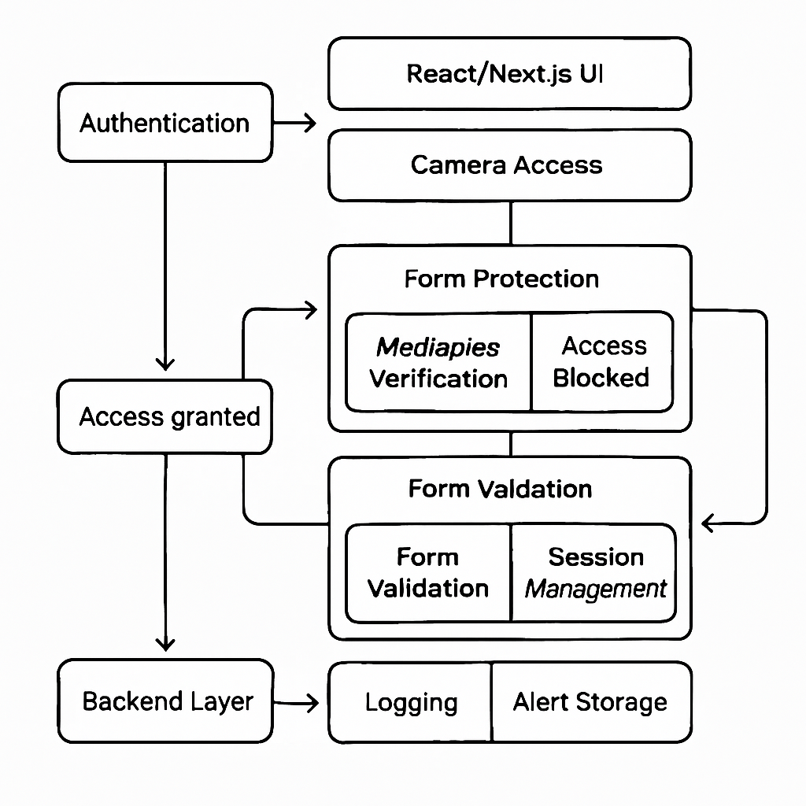
H. Methodology
Emphasizes on simplicity, modularity and security. Leveraging modern open-source tools while keeping resource requirements minimal. Unlike traditional proctoring or form management systems, Form Shell integrates a lightweight verification layer directly into existing forms, thereby improving integrity without requiring expensive infrastructure.

The application is structured into the following logical modules:

Authentication Module: Ensures the user is verified before form access using Mediapipe-based face or gesture recognition.
Form Protection Module: Wraps around existing forms and ensures that duplicate or suspicious submissions are flagged.
Logging and Alert Module: Records user activity and generates alerts in case of fraudulent attempts.

The design process begins with identifying core security requirements such as identity verification, submission control and response logging. These are modeled into functional modules that interact seamlessly with the presentation layer (the form UI).

The data flow is structured in three tiers:

Presentation Layer: Implemented using React/Next.js, it handles user interaction, camera access and the display of form elements.
Application Layer: Python or JavaScript scripts integrate Mediapipe for verification, perform form validation and manage session security.
Backend Layer: While a simple file/database logging system is sufficient, this layer ensures activity logs and security flags are stored for analysis.

The verification process follows these steps:

1. The user attempts to access a form.
2. The Form Shell layer activates, performing identity verification through Mediapipe.
3. If all checks pass, the user is allowed access to the form. Otherwise, the attempt is blocked and logged.

Key design choices include the use of Mediapipe for browser-based identity verification, Next.js for modular front-end development, and open-source libraries to ensure zero-cost deployment. This ensures that the application is secure, lightweight and scalable, making it practical for academic and organizational use.

I. Flowchart (Plan of Action)
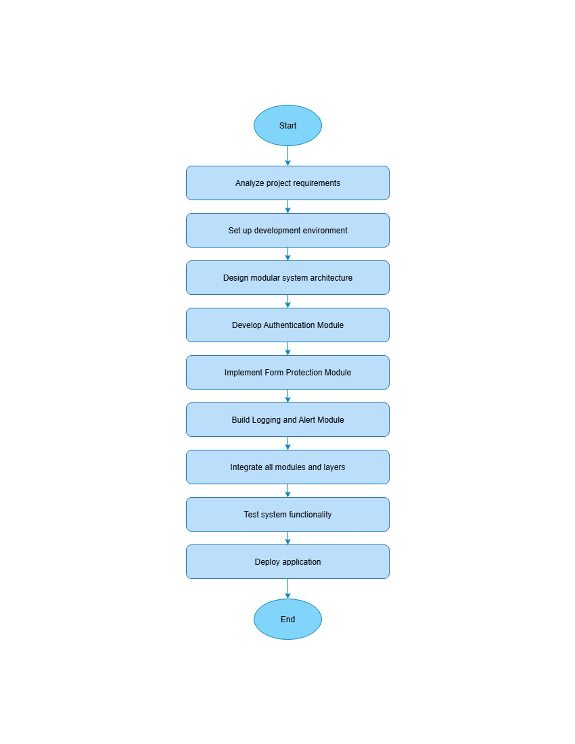
J. Expected Outcome of the project
1. A working prototype of Form Shell that secures existing forms.

2. Demonstration of real-time verification using Mediapipe (face/gesture).

3. Prevention of:
- Cheating attempts
- Duplicate submissions
- Bot-based submissions
- Impersonation attempts
K. Estimated cost |  |  | Source of Fund
Total Estimated Cost: ₹ 0 (NIL) |  |  | NIL
L. References
- The study builds upon concepts from the secure exam browser framework detailed at https://link.springer.com/chapter/10.1007/978-3-030-45697-9_22.
- Insights into secure online exam systems are based on research found at https://ieeexplore.ieee.org/abstract/document/8363325.
- The methodology for efficient online pose tracking is informed by the work available at https://arxiv.org/abs/1802.00977.
- The BlazePose real-time body pose tracking architecture is described in detail at https://arxiv.org/abs/2006.10204.

M. Project Batch members
S.No. | USN | Name |  | Signature with date
1. | ^{4MW23CS171} | ^{SWASTHIK YESH}
2. | _{4MW23CS173} | _{TEJAS NAYAK}
3. | _{4MW23CS178} | _{V SUHAAN ACHARYA}
4. | _{4MW24CS402} | _{NANDAN NAIK}
N. Accepted/Rejected:
O. Suggestions for implementation:
P. Guidance
Guide (s) allotted |  |  | Guide Name and Signature (s) with date
1. Guide

Q. Review Comments/Suggestions

Accept/Modify/Reject

Reviewer Name and Signature

